Job Description | Housing Support Worker  Ofsted Registered Supported Accommodation  Unaccompanied asylum-seeking children and refugees

Positive Action in Recruitment
The new positive action legal provisions mean that it is not unlawful to recruit or promote a candidate who is of equal merit to another candidate, if the chair of the recruitment panel reasonably thinks the candidate has a protected characteristic that is underrepresented in the workforce; or that people with that characteristic suffer a disadvantage connected to that characteristic.

Manchester Settlement is currently underrepresented by staff who are: -
- Men
- Disabled
- Non-White British
- LGBTQ+

Pay  3-year scale range  £27480 - £28573  Essential Car User Allowance paid in addition. - £840 per year  Additional pay for on call | Line Manager:  Registered Service Manager
Hours:  35 hours per week  Flexible between 9am – 6pm Mon - Fri  Potential for some evening work  Weekend and Bank Holiday on call rota, minimum of 12 days per year (additional pay) | Period of contract:  Permanent
Location:  Office based.  Daily travel to premises in local area  Occasional travel across Greater Manchester | Main stakeholders:  Supported Housing Team Colleagues, young people residing in houses, social workers and similar professionals
Other benefits:

Employee Assistance Scheme
Discount Scheme
25+ days annual leave (+ bank holidays)

Purpose of the post:
To provide safe, person-centered and trauma-informed support to young asylum seekers and refugees aged 16 - 25 living in Ofsted-registered supported accommodation, promoting their welfare, safeguarding, emotional wellbeing and progression towards independence in line with support plans, risk assessments, placement plans, organisational policies and the Supported Accommodation (England) Regulations 2023.

The main things you will be asked to do in this role:
- Work in line with the organisation’s values, statement of purpose, safeguarding procedures and the requirements of Ofsted-registered supported accommodation for young people.
- Provide consistent day-to-day support to young people, helping to promote their safety and wellbeing while developing practical independence skills.
- Build positive, professional relationships with young people, using a person-centered, trauma-informed and culturally responsive approach.
- Contribute to and deliver individual support plans, key work sessions, risk assessments and placement plans, ensuring support is tailored to identified needs, goals and outcomes.
- Contribute to the design and delivery of group work sessions to improve engagement, enjoyment and ultimately outcomes for young people
- Promote participation in education, training, employment, health appointments, life skills, community engagement and positive activities.
- Maintain accurate, timely and professional records, case notes, incident reports and outcome-focused documentation in line with organisational procedures, confidentiality requirements and data protection legislation.
- Recognise, respond to and report safeguarding concerns promptly, including concerns relating to exploitation, trafficking, going missing, self-harm, abuse, neglect and emotional wellbeing, in line with child protection procedures.
- Work effectively with social workers, personal advisers, education providers, health services, immigration advisers, interpreters and other relevant professionals to support safe and coordinated care.
- Support young people to understand their rights, entitlements, house expectations, complaints processes and how to access advocacy or additional help where needed.
- Assist in maintaining safe, clean and suitable accommodation, undertaking property checks and reporting repairs, hazards and health and safety concerns in a timely manner.
- Always maintain appropriate professional boundaries, contribute to team meetings, supervision and training, and work in a way that supports reflective practice and continuous improvement.
- Work flexibly in line with service needs, including occasional evenings, weekends, bank holidays and participation in the on-call rota.
- Undertake any other duties reasonably required that are consistent with the purpose and responsibilities of the post.

General asks of everyone that works as part of the Manchester Settlement Supported Housing Team
- Support us in our charitable purpose, helping us to achieve our strategic aims and using our values as outlined below to underpin all that you do.
- Behave in a professional manner and adhere to our policies and procedures including safeguarding, health and safety, and data protection.
- Be inclusive and work to combat all forms of discrimination and disadvantage, ensuring that the principles of equitable opportunities and social justice are implemented in your work.
- Help us to achieve our strategic aims and priorities by contributing your skills and experience to projects and tasks when required.

Our charitable purpose, strategy and values
The Manchester Settlement Team is vital in achieving the charity’s purpose:
CREATING STRONGER COMMUNITIES TOGETHER

It is vital that all of our team understand, live and breathe our values in everything they do.

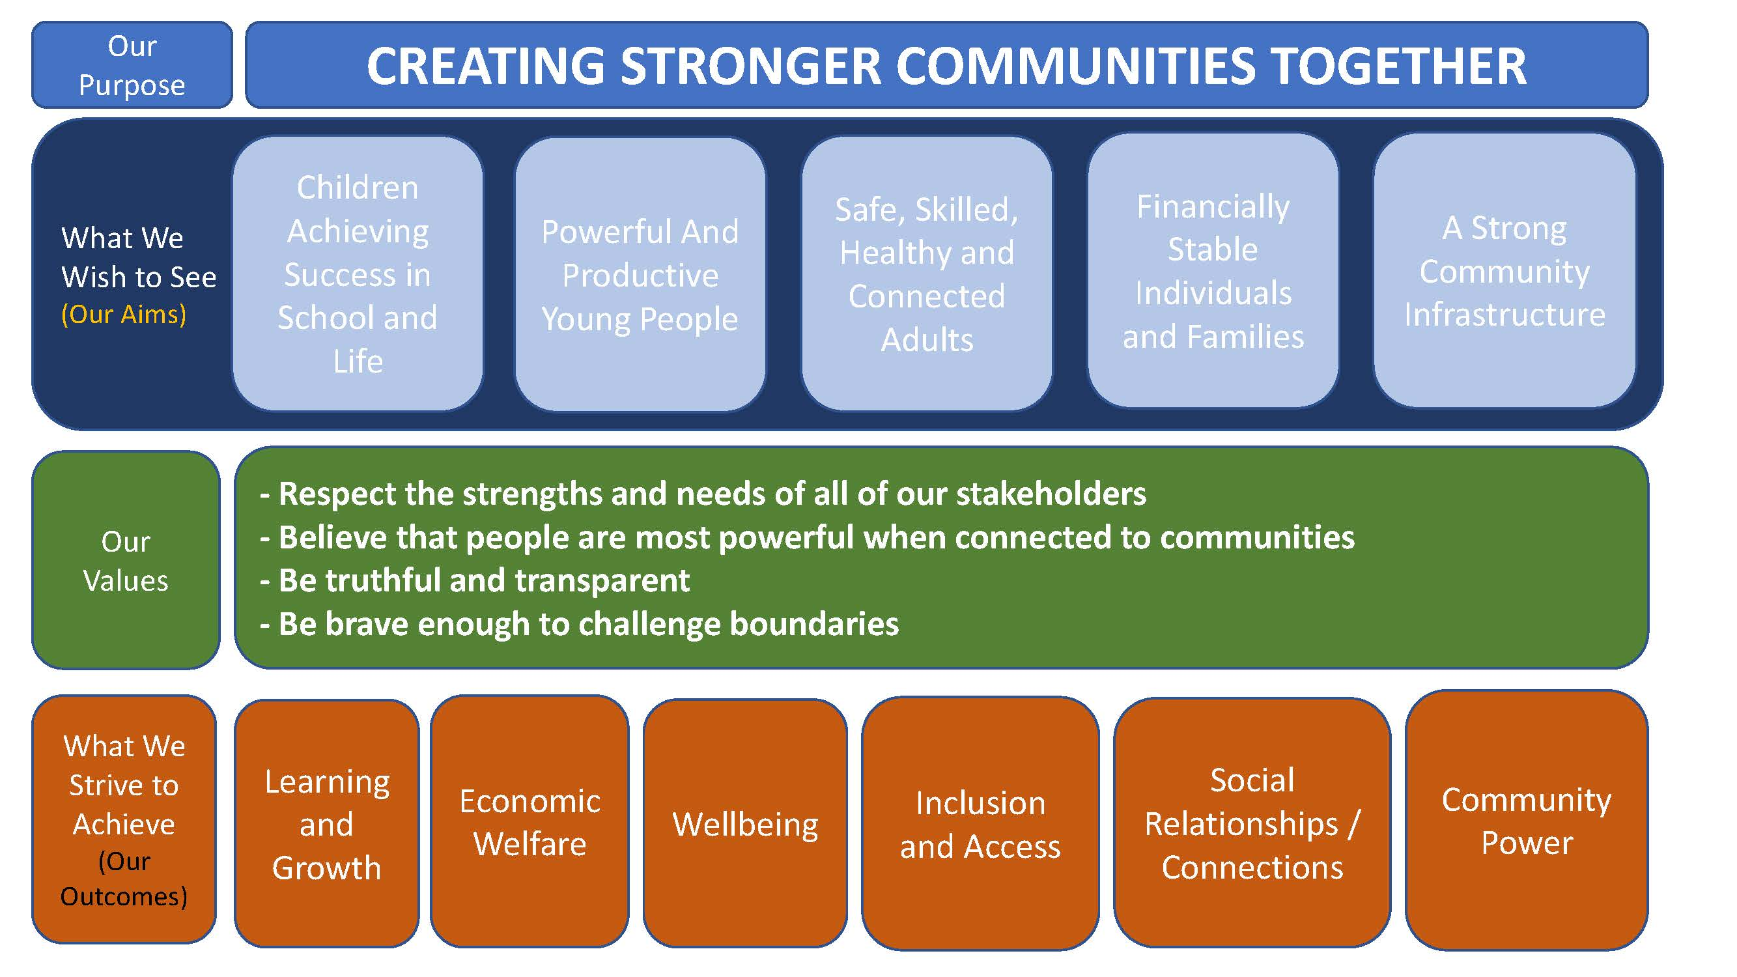

Person Specification | Housing Support Worker

The ideal candidate for this role will be
- Compassionate, resilient, and passionate about supporting UASC care leavers.
- Committed to helping young people achieve independence and positive outcomes.
- Experienced in using a trauma-informed and person-centered approach.
- Able to build trusting, professional relationships while maintaining clear boundaries.
- Culturally aware, empathetic, and respectful of diverse backgrounds and experiences.
- Confident supporting young people who may have experienced trauma, displacement, or loss.
- Skilled at working independently and collaboratively with partner agencies and professionals.
- Organised, reliable, and able to manage safeguarding responsibilities effectively.
- Committed to promoting the welfare, rights, and personal development of young people in line with Ofsted Supported Accommodation Standards.
- Motivated to support young people in developing practical, emotional, and social skills for independent living.

The recruitment process (application, interview, and any other activities) are your opportunity to demonstrate the following skills (able to), experience (experience of), and knowledge (knowledge of):

Experience
Essential
- Experience of working with vulnerable children and young people and providing safe, consistent, and respectful support.
- Experience of contributing to support planning, key work sessions, risk assessments, outcome monitoring, and case recording.
- Experience of working collaboratively with colleagues and partner agencies to support positive outcomes for young people.
- Experience of maintaining accurate records and using digital systems, including Microsoft Office applications and case management databases.
Desirable
- Experience of working with Unaccompanied Asylum-Seeking Children (UASC) and care leavers.
- Experience of working within supported accommodation or semi-independent living services.
- Experience of supporting young people with immigration, asylum, or resettlement-related needs.

Knowledge
Essential
- Knowledge of safeguarding, child protection, professional boundaries, and the importance of timely reporting and escalation of concerns.
- Knowledge of trauma-informed and child-centred approaches to supporting young people.
- Knowledge of equality, diversity, inclusion, and anti-discriminatory practice.
- Knowledge of the needs and challenges faced by vulnerable young people, including UASC care leavers.
- Knowledge of health and safety responsibilities within supported accommodation settings, including identifying and reporting hazards and maintenance concerns.
- Knowledge of the standards expected within Ofsted Supported Accommodation services.
- Knowledge of safer recruitment principles and professional conduct when working with children and young people.
Desirable
- Knowledge of local authority leaving care services and pathway planning processes.
- Knowledge of relevant legislation, guidance, and good practice relating to care leavers and supported accommodation.

Skills and Abilities
Essential
- Ability to communicate effectively with young people, colleagues, and partner agencies, both verbally and in writing.
- Ability to build positive, professional relationships with young people from diverse cultural backgrounds.
- Ability to work collaboratively as part of a team and use initiative when working independently.
- Ability to maintain professional boundaries while providing supportive and compassionate care.
- Ability to manage competing priorities and respond calmly and effectively in challenging situations.
- Ability to maintain accurate, clear, and timely records.
- Ability to support young people to develop independence, confidence, and life skills.
- Ability to work in a culturally responsive and inclusive manner.

Qualifications and Other Requirements
Essential
- Enhanced DBS check suitable for working with children and vulnerable young people or willingness to undertake one.
- Willingness to undergo all safer recruitment checks in line with safeguarding requirements, including identity verification, right to work checks, employment history checks, and satisfactory references.
- Full UK driving licence and access to a suitably insured vehicle for work-related travel between service locations and community venues.

Desirable
- Level 3 qualification in Health & Social Care, Children & Young People, Youth Work, Housing Support, or a related field.
- Relevant training in safeguarding, trauma-informed practice, mental health awareness, behaviour support, or first aid.

Personal qualities – These are things which we ask for from everybody who works as part of the Manchester Settlement team:
• Be committed to our values.
• Work and collaborate effectively as part of the wider team.
• Seek opportunities to develop yourself and others.
• Be committed to social justice and equity.

Working with Manchester Settlement

As a member of the Manchester Settlement team you will also benefit from:
  - Membership of Health Assured – Employee Assistance Programme.
  - Ongoing professional development.
  - Cycle and tech loan schemes.

For more information on the work that we do please visit www.manchestersettlement.org.uk




